FACULTY PROFILE DETAILS

* Full Name and Designation
HARIKRISHNAN NAIR S
Asst Professor
Mechanical Engineering

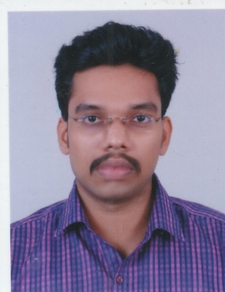
Mail id: harikrishnannairs@jcmcsiit.ac.in
Contact no: +91-9037180610

* Educational Qualifications
Course | University/ Board | Institution | Year | Aggregate
M Tech,  Machine Design | Kerala University | SCT COLLEGE OF ENGINEERING | 2012-2014 | 9.1
B-Tech ,  Mechanical Engineering | Kerala University | LMCST,  Kuttichal, TVM | 2008-2012 | 8.1
12th | CBSE | Saraswathi Vidyalaya, Vattiyoorkavu p.o. | 2008 | 85%
10th | ICSE | Christ Nagar Higher Secondary School,kowdiar | 2006 | 77%

* Areas of Specialization
  - Vibration analysis
  - Machine design
  - Composite product design and analysis
  - Static stress analysis and theoretical evaluation
  - Composite modelling using CAE software
  - Strength based design of components
  - Thermal engineering

* B.Tech Project/Research Area
Vibration analysis of the launch vehicle structure at VSSC
* M.Tech Thesis/Research Area
• Design and development of a composite conical engine mount structure for launch vehicle applications , work done at CMSE, VSSC
* Additional Certifications, Courses, or Training Programmes Completed
- Worked as student council coordinator
- Worked as add on course coordinator of mechanical engineering department
- Associated with student chapters like ISNT (INDIAN SOCIETY FOR NON-DESTRUCTIVE TESTING) and Institution of Engineers (India) [IEI]
- Attended student mentoring programs and mentored many students based on mentoring scheme
- Assisted in coordinating Career Guidance and Placement cell (CGPC) activities and finishing school activities
- Handled all mechanical core subjects, inter disciplinary subject and mechanical laboratory courses
- Conducted industry institution related project coordination.
- Worked as coordinator in NAAC criterion
- Part of discipline committee and anti-ragging team
- Appointed as observer to evaluate university examinations
- Participated in various national and international conferences
- Worked as coordinator for club activities of college
- Organize and maintain the files as per the ISO Guidelines
* Professional Memberships and Affiliations
- Life Member ISTE (Indian Society for Technical Education)
- Associated with student chapters like ISNT (INDIAN SOCIETY FOR NON-DESTRUCTIVE TESTING) and Institution of Engineers (India) [IEI]
* Awards, Achievements, and Recognitions
- Secured 4th position in M.Tech (Machine design) exams conducted by Kerala University in the year 2014.
- Secured first position in Sree Chitra Thirunal College of Engineering in M.Tech Degree Examination (Machine Design)
- Placed in first class with distinction for both B.Tech and M.Tech degree examinations.

* Teaching Experience and Industry Experience (if applicable)
- Nine years and eight months of teaching experience in mechanical engineering

- Guided more than 150 technical undergraduate projects and is a part of project review panel

- Worked as coordinator in various student activities

- Worked as staff advisor for many batches

